**Apply Inferential Statistics**

**Are there strong correlations between pairs of independent variables or between an independent and a dependent variable?**

**Numerical Variables**

We use correlation to see how the numerical features are related to each other.

corrMatrix **=** cleveland

​

corrMatrix **=** corrMatrix.corr()

​

fig, ax **=** plt.subplots(figsize**=**(15,10))

​

ax **=** sns.heatmap(corrMatrix,

annot**=True**,

linewidths**=**0.5,

fmt**=**".2f",

cmap**=**"YlGnBu");

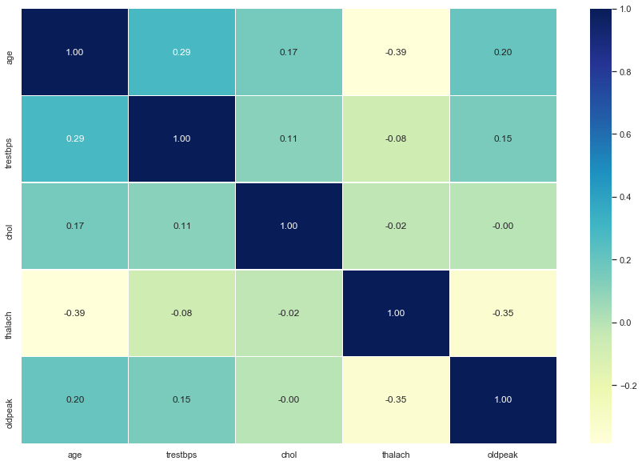

**INSIGHT:** There are no strong correlations between numerical independent features.

**What are the most appropriate tests to use to analyse these relationships?**

**Numerical Variables v/s Categorical Variables**

We use ANOVA to see how the numerical features are related to categorical features.

The one-way analysis of variance (ANOVA) is used to determine whether there are any statistically significant differences between the means of two or more independent (unrelated) groups (although you tend to only see it used when there are a minimum of three, rather than two groups).

cleveland_anova **=** cleveland

​

cleveland_anova **=** cleveland_anova.drop(['sex', 'cp', 'fbs', 'restecg', 'exang', 'slope', 'ca', 'thal'], axis**=**1)

cleveland_anova

|  |  |  |  |  |  |  |
| --- | --- | --- | --- | --- | --- | --- |

**import** scipy.stats **as** stats

​

*# Significance level*

alpha **=** 0.05

*# Perform One Way ANOVA*

outcome **=** stats.f_oneway(cleveland_anova['age'], cleveland_anova['trestbps'], cleveland_anova['chol'],

cleveland_anova['thalach'], cleveland_anova['oldpeak'])

*# gettin p-value of test*

p_value**=** outcome[1]

​

*#Null hypothesis mu_1 = mu_2 = mu_3 = mu_4 = mu_5*

**if** p_value **<=** alpha:

*# we reject null hypothesis*

print('Null hypothesis is unlikely to except.')

**else**:

*# we reject alternative hypothesis*

print('Null hypothesis cannot be rejected.')

Null hypothesis is unlikely to except.

**INSIGHT:** We reject null hypothesis.

**Categorical Variables**

We use Chi Square to see how the numerical features are related to categorical features.

**Sex**

fig, ax **=** plt.subplots(figsize**=**(10,6))

​

male **=** len(cleveland[cleveland['sex'] **==** 'Male'])

female **=** len(cleveland[cleveland['sex'] **==** 'Female'])

ax **=** plt.pie(x**=**[male, female], explode**=**(0, 0), labels**=**['Male', 'Female'], autopct**=**'%1.2f%%', startangle**=**90)

plt.show()

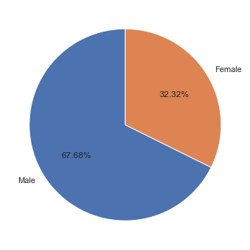

absence **=** cleveland[cleveland["class"] **==** 'Absence']["sex"].sort_values()

presence **=** cleveland[cleveland["class"] **==** 'Presence']["sex"].sort_values()

f, axes **=** plt.subplots(1, 2, figsize **=** (15,5))

sns.countplot(absence, data**=**cleveland,ax**=**axes[0]).set_title('Absence of Heart Disease')

sns.countplot(presence, data**=**cleveland,ax**=**axes[1]).set_title('Presence of Heart Disease')

plt.show()

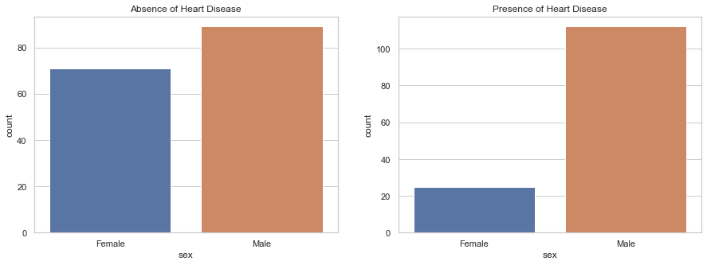

*# Chi-square test of independence of variables*

cont **=** pd.crosstab(cleveland['sex'], cleveland['class'])

chi_stat **=** stats.chi2_contingency(cont)

print(f'Chi statistics is {chi_stat[0]} and p value is {chi_stat[1]}')

*# Null hypothesis : Gender is not associated with Goal*

*# Alternate hypothesis : Gender is associated with Goal*

Chi statistics is 21.851612168613475 and p value is 2.945690038078843e-06

**INSIGHT:** As expected, given the low p-value(2.666712348180942e-06), so we reject null hypothesis and the test result detect a significant relationship between Sex and Class.

**Chest Pain Type**

x **=** [len(cleveland[cleveland['cp'] **==** 'Typical angina']),len(cleveland[cleveland['cp'] **==** 'Atypical angina']), len(cleveland[cleveland['cp'] **==** 'Non-anginal pain']), len(cleveland[cleveland['cp'] **==** 'Asymptomatic pain'])]

plt.pie(x, data**=**cleveland, labels**=**['CP(1) Typical angina', 'CP(2) Atypical angina', 'CP(3) Non-anginal pain', 'CP(4) Asymptomatic pain'], autopct**=**'%1.2f%%',startangle**=**90)

plt.show()

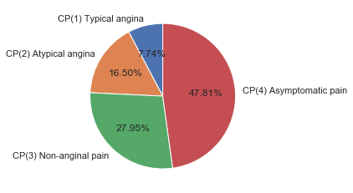

f, axes **=** plt.subplots(1,2,figsize**=**(15,5))

absence **=** cleveland[cleveland["class"]**==**'Absence']["cp"]

presence **=** cleveland[cleveland["class"]**==**'Presence']["cp"]

sns.countplot(absence, data**=**cleveland,ax**=**axes[0]).set_title('Absence of Heart Disease')

sns.countplot(presence, data**=**cleveland,ax**=**axes[1]).set_title('Presence of Heart Disease')

plt.show()

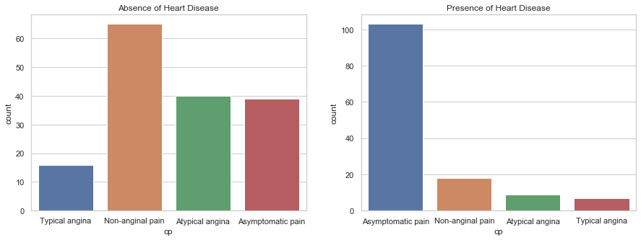

*# Chi-square test of independence of variables*

cont **=** pd.crosstab(cleveland['cp'], cleveland['class'])

chi_stat **=** stats.chi2_contingency(cont)

print(f'Chi statistics is {chi_stat[0]} and p value is {chi_stat[1]}')

*# Null hypothesis : Chest Pain is not associated with Goal*

*# Alternate hypothesis : Chest Pain is associated with Goal*

Chi statistics is 77.27579978222383 and p value is 1.1782838465918115e-16

**INSIGHT:** As expected, given the low p-value, so we reject null hypothesis and the test result detect a significant relationship between cp and class. Presence of disease graph have 104 patients with Chest pain type 4 much higher as compared to other chest pain. So, Asymptomatic pain can high predictive power.

**Fasting Blood Sugar**

sizes **=** [len(cleveland[cleveland['fbs'] **==** 'No']), len(cleveland[cleveland['fbs'] **==** 'Yes'])]

labels **=** ['No', 'Yes']

plt.pie(x**=**sizes, labels**=**labels, explode**=**(0.1, 0), autopct**=**"%1.2f%%", startangle**=**90)

plt.show()

*# Fbs: fasting blood sugar > 120 mg/dl (1 = true; 0 = false)*

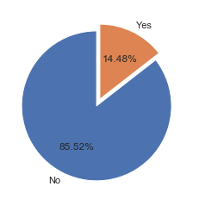

f, axes **=** plt.subplots(1,2,figsize**=**(15,5))

absence **=** cleveland[cleveland["class"]**==**'Absence']["fbs"]

presence **=** cleveland[cleveland["class"]**==**'Presence']["fbs"]

sns.countplot(absence, data**=**cleveland,ax**=**axes[0]).set_title('Absence of Heart Disease')

sns.countplot(presence, data**=**cleveland,ax**=**axes[1]).set_title('Presence of Heart Disease')

plt.show()

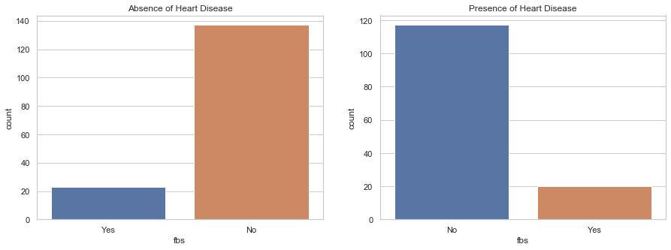

*# Chi-square test of independence of variables*

cont **=** pd.crosstab(cleveland['fbs'],cleveland['class'])

chi_stat **=** stats.chi2_contingency(cont)

print(f'Chi statistics is {chi_stat[0]} and p value is {chi_stat[1]}')

*# Null hypothesis : FBS is not associated with Goal*

*# Alternate hypothesis : FBS is associated with Goal*

Chi statistics is 0.01228173970336428 and p value is 0.91175669783748

**INSIGHT:** As expected, given the high p-value, so we fail to reject null hypothesis and the test result detect a non-significant relationship between Fbs and Goal. Most individuals did not have fasting blood sugar levels greater than 120 mg/dL. This did not change greatly when the data was divided based on the presence of disease.So, FBS is not a predictive feature.

**Resting ECG Results**

sizes **=** [len(cleveland[cleveland['restecg'] **==**'Normal']), len(cleveland[cleveland['restecg']**==**'Abnormality']), len(cleveland[cleveland['restecg']**==**'Hypertrophy'])]

labels **=** ['Normal', 'ST-T wave abnormality', 'definite left ventricular hypertrophy by Estes criteria']

plt.pie(x**=**sizes, labels**=**labels, explode**=**(0, 0, 0), autopct**=**"%1.2f%%", startangle**=**90)

plt.show()

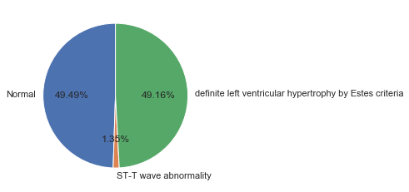

f, axes **=** plt.subplots(1,2,figsize**=**(15,5))

absence **=** cleveland[cleveland["class"]**==**'Absence']["restecg"]

presence **=** cleveland[cleveland["class"]**==**'Presence']["restecg"]

sns.countplot(absence, data**=**cleveland,ax**=**axes[0],order**=**['Normal', 'Abnormality', 'Hypertrophy']).set_title('Absence of Heart Disease')

sns.countplot(presence,ax**=**axes[1],order**=**['Normal', 'Abnormality', 'Hypertrophy']).set_title('Presence of Heart Disease')

plt.show()

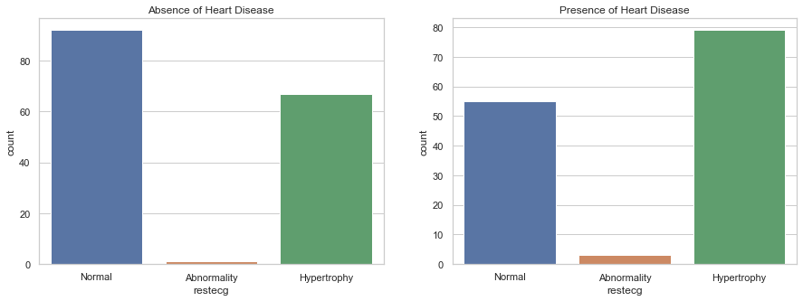

print(f'Probability of Hypertropy in disease cohorts {presence[presence**==**"Hypertrophy"].value_counts()**/**len(presence)}')

print(f'Probability of Hypertropy in non-disease cohorts {absence[absence**==**"Hypertrophy"].value_counts()**/**len(absence)}')

Probability of Hypertropy in disease cohorts Hypertrophy 0.576642

Name: restecg, dtype: float64

Probability of Hypertropy in non-disease cohorts Hypertrophy 0.41875

Name: restecg, dtype: float64

cont **=** pd.crosstab(cleveland['restecg'],cleveland['class'])

chi_stat **=** stats.chi2_contingency(cont)

print(f'Chi statistics is {chi_stat[0]} and p value is {chi_stat[1]}')

*#Null hypothesis : Exang is not associated with Goal*

*#Alternate hypothesis : Exang is associated with Goal*

Chi statistics is 9.575507229251564 and p value is 0.008331151353680854

**INSIGHT**: Most patients exhibited normal resting electrocardiograhic results . However, a higher proportion of diseased patients had hypertropy suggesting that this feature may contribute some predictive power.

**Exercise Induced Angina**

sns.countplot(data **=** cleveland , x **=** 'exang')

*# exercise induced angina (1 = yes; 0 = no)*

Out[42]:

<matplotlib.axes._subplots.AxesSubplot at 0x1e913f88448>

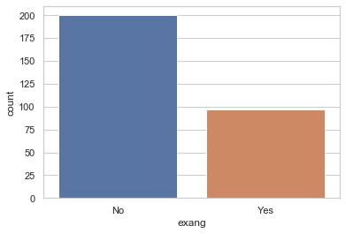

f, axes **=** plt.subplots(1,2,figsize**=**(15,5))

absence **=** cleveland[cleveland["class"]**==**'Absence']["exang"]

presence **=** cleveland[cleveland["class"]**==**'Presence']["exang"]

sns.countplot(absence, data**=**cleveland,ax**=**axes[0]).set_title('Absence of Heart Disease')

sns.countplot(presence, data**=**cleveland,ax**=**axes[1]).set_title('Presence of Heart Disease')

plt.show()

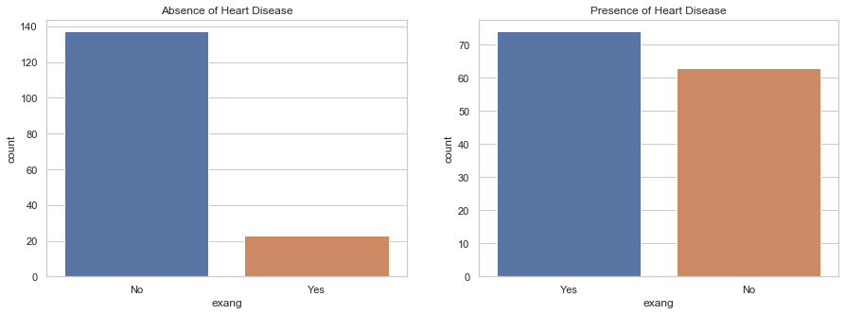

*# Chi-square test of independence of variables*

cont **=** pd.crosstab(cleveland['exang'], cleveland['class'])

chi_stat **=** stats.chi2_contingency(cont)

print(f'Chi statistics is {chi_stat[0]} and p value is {chi_stat[1]}')

*# Null hypothesis : Exang is not associated with Goal*

*# Alternate hypothesis : Exang is associated with Goal*

Chi statistics is 50.9425597633616 and p value is 9.510884265909016e-13

**INSIGHT:** As expected, given the low p-value, so we reject null hypothesis and the test result detect a significant relationship between Exang and Goal. Significantly more patients in the diseased cohort displayed exercise induced angina. This feature should be strongly predictive.

**Peak Exercise ST Segment**

sns.countplot(data **=** cleveland , x **=** 'slope')

Out[45]:

<matplotlib.axes._subplots.AxesSubplot at 0x1e9139fbac8>

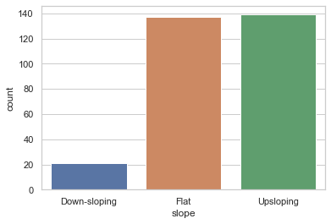

f, axes **=** plt.subplots(1,2,figsize**=**(15,5))

absence **=** cleveland[cleveland["class"]**==**'Absence']["slope"]

presence **=** cleveland[cleveland["class"]**==**'Presence']["slope"]

sns.countplot(absence, data**=**cleveland,ax**=**axes[0]).set_title('Absence of Heart Disease')

sns.countplot(presence, data**=**cleveland,ax**=**axes[1]).set_title('Presence of Heart Disease')

plt.show()

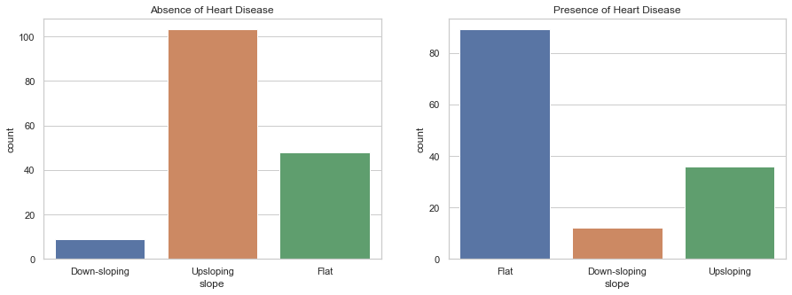

*# Chi-square test of independence of variables*

cont **=** pd.crosstab(cleveland['slope'],cleveland['class'])

chi_stat **=** stats.chi2_contingency(cont)

print(f'Chi statistics is {chi_stat[0]} and p value is {chi_stat[1]}')

*#Null hypothesis : Slope is not associated with Goal*

*#Alternate hypothesis : Slope is associated with Goal*

Chi statistics is 43.47317755212573 and p value is 3.630107106911135e-10

**INSIGHT:** As expected, given the low p-value, so we reject null hypothesis and the test result detect a significant relationship between Slope and Goal. Significantly more patients in the non-diseased cohort displayed Slope-Flat. This feature could be strongly predictive. The slope of the peak exercise ST segment differed between the non-disease and diseased cohorts with the majority of cardiac disease patients exhibiting a flat ST slope(value = 2).This can also have good predictive power.

**Number of Blood Vessels**

sns.countplot(data **=** cleveland , x **=** 'ca')

Out[48]:

<matplotlib.axes._subplots.AxesSubplot at 0x1e913f1d4c8>

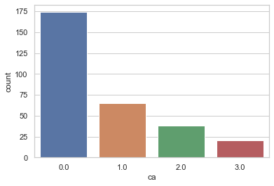

f, axes **=** plt.subplots(1,2,figsize**=**(15,5))

absence **=** cleveland[cleveland["class"]**==**'Absence']["ca"]

presence **=** cleveland[cleveland["class"]**==**'Presence']["ca"]

sns.countplot(absence, data**=**cleveland,ax**=**axes[0]).set_title('Absence of Heart Disease')

sns.countplot(presence, data**=**cleveland,ax**=**axes[1]).set_title('Presence of Heart Disease')

plt.show()

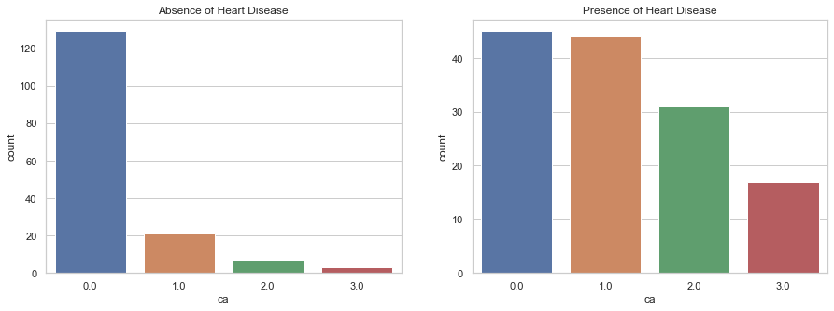

*# Chi-square test of independence of variables*

cont **=** pd.crosstab(cleveland['ca'],cleveland['class'])

chi_stat **=** stats.chi2_contingency(cont)

print(f'Chi statistics is {chi_stat[0]} and p value is {chi_stat[1]}')

*# Null hypothesis : CA is not associated with Goal*

*# Alternate hypothesis : CA is associated with Goal*

Chi statistics is 72.30053062466945 and p value is 1.37257765344901e-15

**INSIGHT:** As expected, given the low p-value, so we reject null hypothesis and the test result detect a significant relationship between CA and Goal. Significantly more patients in the diseased cohort has number of blood vessels greater than 1. This feature should be strongly predictive.